Grace Community Church 2018 VBS Registration Form

Child's Name: _____________________________________________________________
Birthday: Age: Grade in Fall 2018:______________
Address: ___________________________________________________________________
City: ___________________________ Postal Code: _________________________
Phone: ______________________________E-mail:________________________________
Parent/Guardian(s) Name(s): ________________________________________________
Emergency Contact Name (available 9am-12pm): ____________________________________
Emergency Contact’s Phone: _(______)_______________________
Allergies/Medical Conditions: _______________________________________________
Health Card Number: ______________________________________
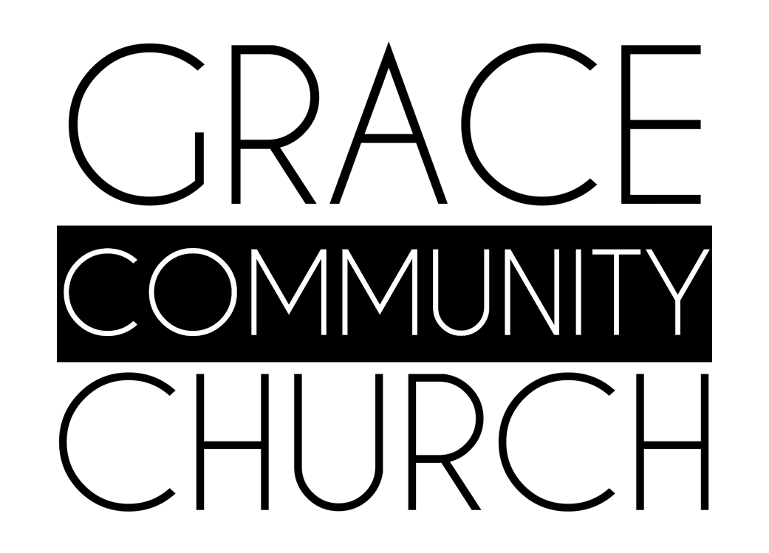
Is this your child’s first time attending? Please circle: Yes/No
Will you be attending the Friday lunch BBQ? Please circle Yes/No

Accident Waiver
In the event that the student as named above suffers an accident on the property of Grace Community Church, I acknowledge that the church has made effort to ensure safety, and therefore I do not hold the Director of the VBS, or the volunteers, or the church and its members responsible.

Medical Waiver
I authorize the administration of any first aid treatment necessary in VBS and in the case of medical emergency authorize adult volunteers of Grace Community Church, as agent(s) for the undersigned, to transport in a private vehicle/taxi/emergency vehicle this child to a healthcare facility and seek appropriate medical care from the required healthcare professionals. I further release from liability Grace Community Church, any of its ministries or leaders in the event of an accident en route, during and returning from the above mentioned event. This agreement does not apply to claims for intentional misconduct or gross negligence

Media Release
Throughout the week we take pictures of the children enjoying their activities to present throughout the week and to use for promotion. I hereby consent to having my child photographed.
Receipt No.

Parent/Guardian Signature:

RECEIPT No.
Date Registered for VBS:________________  Name of Registrant:_____________________  Staff Signature: | Paid: $25 $60  Cash Cheque  Cheque #_______

